Dataset 9: Stress & Working Memory

Scenario Overview
Students rated their perceived stress (1–10) before completing a working memory task (score out of 50). The scatterplot shows the relationship between stress and working memory performance.

Data Summary
Perceived stress (1–10) | Working memory score (out of 50)
1 | 44
2 | 46
3 | 42
4 | 41
5 | 45
6 | 37
7 | 43
8 | 39
9 | 36
10 | 40

Figure
Figure 1. Perceived stress vs working memory score. Pearson’s correlation (r) = -0.68.
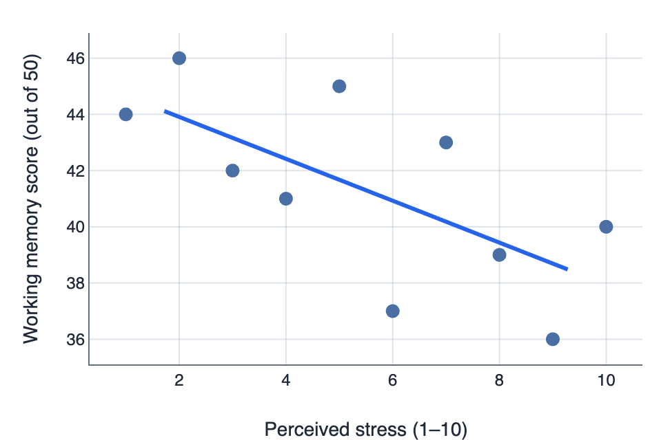

IA1 Practice Questions
- Estimate: Using the line of best fit, estimate the working memory score at a stress rating of 8.

- Describe: Describe the strength and direction of the correlation using the r-value provided.

- Identify: Identify the trend and any potential outlier.

- Explain: Explain what a negative correlation implies about the relationship between stress and memory.

- Infer: Infer one implication for exam preparation.

- Justify: Justify why third variables should be considered.

